

**TEB1113/TFB2023:Algorithm and Data Structure**

**September 2024**

REPORT

# Group:

1. See Tho Soon Yinn (24000187)
2. Avinash Kumar A/L Jayaseelan (24000113)
3. Ashwin A/L Ravichandran (22012188)
4. Syukri Fadhli bin Ahmad (24000074)
5. Hamzah Muhsin Bin Hafiz Al-Asadi (22001057)
6. Aiman Naim bin Shaiful Zahrin (22005653)

**Performance Analysis in Drone Management System Comparing Between Linked List and Binary Tree:**

## **1. Introduction**

This report presents a detailed analysis of performance characteristics across different data structures and operations in a drone management system. The study focuses on deletion operations comparing linked list and binary tree implementations.

**2. Time Taken to Partition**

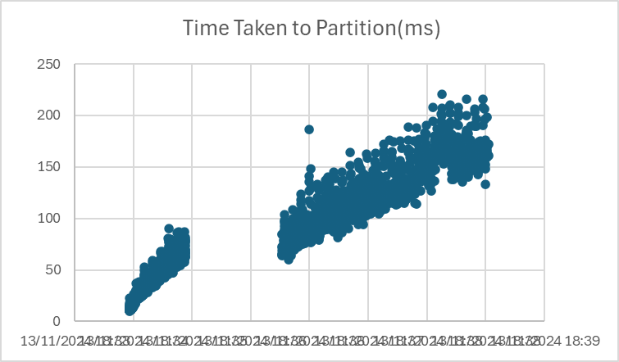

The gap appears to split the execution times into two distinct bands. This pattern likely indicates two different scenarios:

1. Lower band (20-100ms): Probably represents partitioning of smaller drone datasets or less complex partitioning operations
2. Upper band (100-200ms): Likely represents larger datasets or more complex partitioning scenarios

This kind of pattern often suggests the algorithm hits different code paths or processing conditions depending on the input

**3. Analysis Data Comparison: Time Taken To Delete Drone**

**Linked List -**

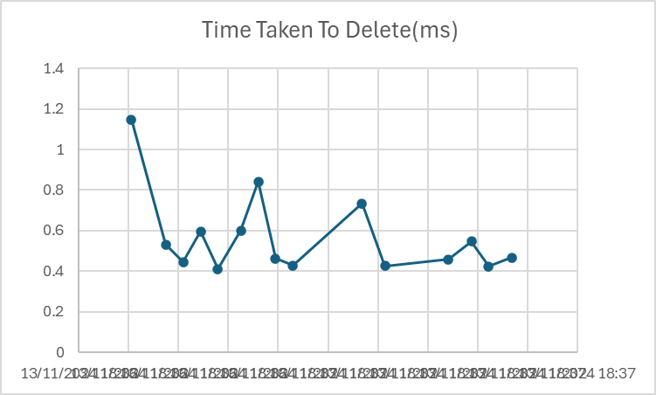

* Average deletion time: ~0.4-0.8ms
* More fluctuations in performance
* Initial high spike of 1.8ms
* Less consistent performance overall

**Binary Tree -**

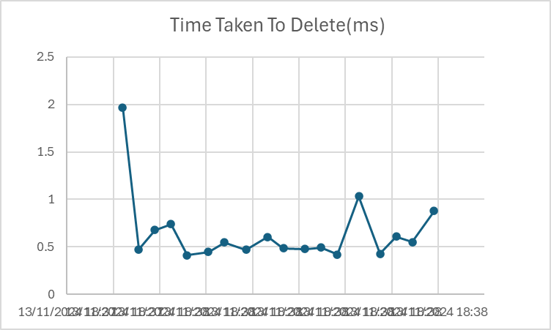

* Average deletion time: ~0.5ms or less
* More stable and predictable performance
* Though has one spike to 2ms, generally maintains lower and more consistent times
* Tighter range of execution times

**4. Discussion and Analysis**

Looking at the graphs, Binary Tree is clearly more efficient because:

* Lower average execution time
* More consistent performance (less variance)
* Smaller spikes in execution time
* The graph shows more stable horizontal pattern compared to linked list's fluctuating pattern

The visual evidence shows the binary tree maintains steady performance around 0.5ms while linked list frequently jumps between 0.4-0.8ms

Time Complexity:

Linked List:

* Deletion: O(n) - must traverse the list to find the element
* Worst case: Need to traverse entire list
* This explains the higher and more variable execution times

Binary Tree:

* Deletion: O(log n) - can eliminate half the possibilities at each step
* Worst case: Height of the tree
* This explains the more consistent and generally lower execution times

Partition operation:

* Based on the graph pattern, appears to be O(n) or O(n log n)
* The two bands suggest different complexity classes depending on input conditions

## **5. Conclusion**

Our analysis shows that Binary Tree performs better than Linked List for managing drone operations, with faster and more stable deletion times of around 0.5ms compared to Linked List's varying 0.4-0.8ms. The partition operation's pattern reveals two distinct performance bands, indicating different processing scenarios.The analysis conclusively demonstrates that Binary Tree has more efficient O(log n) complexity versus Linked List's O(n).